UNES
OFFER OF SUMMER CAMPS
July and August 2021
Camp No.1
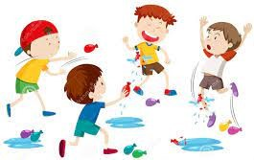
Title: LANGUAGE AND FUN SUMMER CAMP
Date: 05.- 09.07.2021
Camp leaders: Priscila Cabal, Chris Chilová, Heliam Álvarez
Camp description: This week, our summer camp will focus on playing several games to keep kids active and having fun while developing motor skills and putting their language skills into practice in a relaxed and friendly atmosphere.
Main activities:
- team banners and shirts: color t-shirts and cloth banners to create and identify their teams.
- obstacle course: finish an outdoor obstacle course by running, crawling, jumping, climbing, and hitting a target with a bow and arrow.
- excursion: TBA
- minute to win it: a good chance to show their fine motors skills to finish several tasks in one minute
- traditional games: play marbles, the third run, dodgeball, and tag games to keep moving and enhancing gross motor skills.
- digital afternoon: an afternoon to code using the Ozobot and Photon robots as well as dancing to the beats of modern songs while playing PS Move Dance Party.
- art and creativity: perform STEM engineering challenges using a variety of school items.
- laser arena: a trip to Laser Arena where kids will have the chance to play laser tag for one hour.
- survivor challenges: learn useful skills like knot tying, setting up a campfire and a tent.
- water games: get wet and have fun playing water balloon fight, water slide, pass the glass over, flip the sponge, and other games.
- American sports: get to know new American games like kickball and baseball

Camp No.2

Title: HARRY POTTER
Date: 12. - 16.07.2021
Camp leaders: Tinka Verešová, Eliška Medveďová
Camp description: Do you want to know what awaits you at Potter Camp this year? We would not tell even if you used black magic. You don't want to lose a surprise moment. However, we can still tell you something.
You will become a magician who reveals secrets, you will face Lord Voldemort, and as Harry, Ron and Hermione you will experience a lot of tension, learning, fun and laughter. You will all meet in fights, you will collect points and fight for the prize, which will be won by the best faculty. You will attend classes of magic, we will teach you the most important spells, making your own wand. You will also experience lessons of potions and herbology, get to know medicinal plants and make magical elixirs. We will also have Quidditch trainings and at the end of the week a Quidditch tournament.
The fantasy becomes a reality. At Potter Camp, children try many things they've read about in books. They will learn a lot of practical skills, but also something more important – how to play fair, manage to lose, assert yourself, look for solutions, realize an idea. Camp is a school of life. It will also be exciting and great fun.
During the whole week there will be morning warm-ups, relaxation, additional themed games and, of course, everything you create you can take home as inspiration or a gift.

Eliška and Tinka are looking forward to seeing you.

Camp No.3
Title: FUNKYTOWN
Date: 19. - 23.07.2021
Camp leaders: Paula Zamborská, Žofka Šutková
Camp description: Come and have fun with us in the FUNKYTOWN camp – every day will be full of fun. During the camp week you will face various activities to develop creativity, teamwork, but you will also prove your talent. Try a different club every day and find out what you enjoy the most. We will walk through an enchanted country together, dance, learn many interesting things from cynologists. Will your team collect the most points?
Funkytown Program:
- Division into teams, creation of team posters
- Clubs (art, sports, TV Funkytown, reading, board games club, film, touristic)
- Betting game
- Knighting
- Enchanted country
- Let's dance
- Hit it!
- Cynologists / Agility
- Olympics
- Neptune games
- The boy and the girl of Funkytown
- Business
- Fair
- Farewell disco

Camp No.4
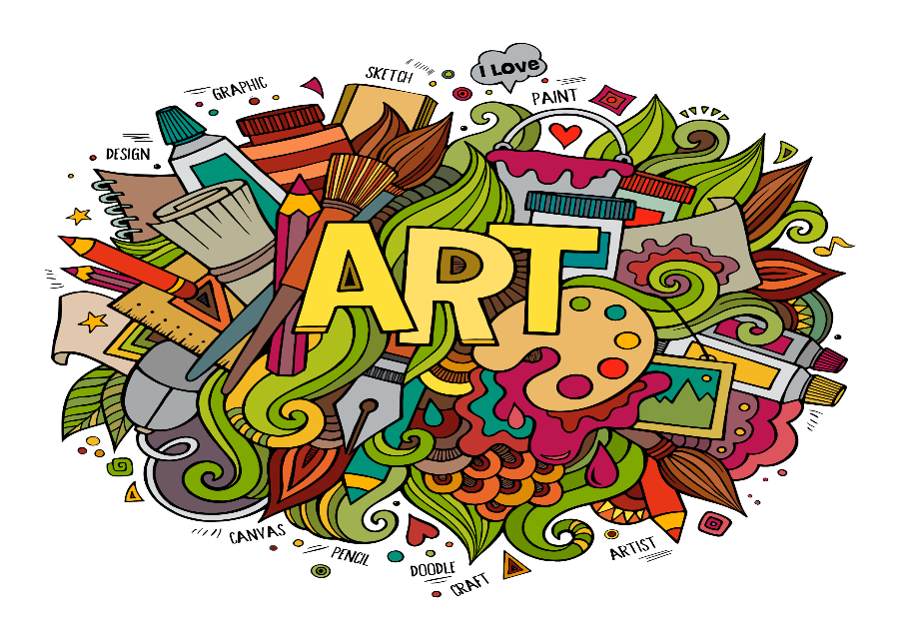

Title: UNES-Artland
Date: 26. - 30.07.2021
Camp leaders: Slávka Laurová, Paťka Jániová
Camp description: The UNES-Artland day camp is focused on children's imagination. Guided children's activity (in the exterior and interior of the school) supports children's responsibility, their thinking, ideas, creativity and also criticism. In a playful and at the same time educational way, children will learn various art and artistic techniques, while developing their natural talent. We will enable children to gain experience and acquire skills for creative activity.
This year, our children will learn (consolidate) many new art techniques – creation from cardboard, ceramic clay, painting on stones... they will also be able to try large-scale acrylic collective painting. They will recycle and create from unnecessary materials. At the end of the week, they make creative gifts that they can give each other. With a little ingenuity, they will also bring home a work painted with acrylic paints on a painting canvas. In addition to creative activities, they will move and play on the playground.
Not only versatile creative activities but also summer games and entertainment, ... spontaneity, curiosity and interest in everything new in life will be synonymous with this year's weekly summer camp UNES-Artland. All this makes our artistic and art weekly summer camp an ideal program for the full-fledged summer enjoyment of your child.

Camp No.5
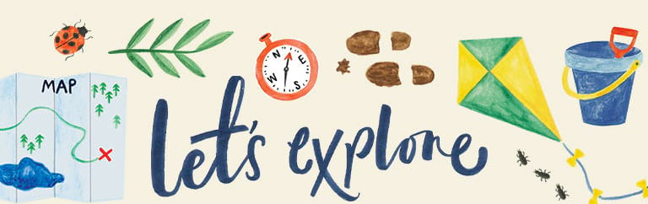
Title: Let´s explore (our history, new places, new sports)
Date: 02.08. - 06.08.2021
Camp leaders: Martinka Malá, Tomáš Sonneschein, Martin Vašš
Camp description: The camp will focus on exploring new places and sports through fun activities and games. Participants will learn the rules of the non-traditional sport of korfball, at the end they will have a tournament for nice prizes. During the week they will visit interesting places in Nitra, they will role-play guides for foreign tourists. There will be camp competitions and activities aimed at developing sports fitness and cooperation between individual children.
Main activities:
- getting to know the dominants of the city of Nitra:
- Zobor, Pyramid, Church of St. Michael - Drážovce
- Nitra Castle and Old Town
- Calvary

- tourist guide: accompanying classmates through the beauties of the city
- korfball : a non-traditional sport that requires the cooperation of boys and girls in one team in the game, explanation of the rules, demonstrations of the game by members of the Korfball club SPU Nitra, creation of teams and matches between them
- sports and camp games : physical activities within the school premises, the City Park and the Birch Grove

Camp No.6
Title: THEATER WEEK
Date: 09. - 13.08.2021
Camp leaders: Juliana Gajdošíková, Zuzka Krajčová
Camp description: From Monday to Friday, participants will develop creativity and imagination, improvisation, discipline, cooperation, acting, artistic aesthetic perception, a sense of dramatic story structure and tension, verbal expression and recitation, as well as movement expression. The teachers will follow the principles of CREATIVE DRAMATICS from the workshop of Mgr.art Marica Šišková. Creative drama is a set of games and exercises that playfully but systematically develop a child's theatrical abilities. Marica Šišková is currently the most successful Slovak teacher of children's actors and director of children's and youth performances, she works at the J. Rosinský Art School in Nitra. Last year, teacher Juliana attended her several-month creative drama course.
What can you expect?
- Games, fun and a lot – a lot of creation
- strengthening concentration, discipline, cooperation and theatrical skills (acting, aesthetic perception)
What will make theater week unconventional?
- The aim of the formation will not be the preparation of a theatrical performance and its presentation to parents. Participants will experience short presentations of their own creations every day, but the final goal of each day will be the very process and personal development of the child.
- Games and exercises will take place in the Slovak language, as well as work with the artistic word will be in the Slovak language
What does such a creative-dramatic game look like?
- For example, the game BOMB is focused on the perception of space and the people in it. The children walk in the designated area to fill each of its fields, but at the same time they avoid one friend who is a bomb,
and if they were near him, they could explode. At the same time, they have chosen another friend who is their shield and will save them from the explosion. Nobody knows who their bomb and shield is. The teacher starts counting down the explosion
and the children accelerate their movement until the explosion finally reveals who was the bomb and shield. During the game, the child concentrates on two teammates so that he does not "lose his life" and thus strengthens the perception of the importance of a co-player on stage. At the same time, he perceives his training as a game and is not aware of it ...
How many games do the teachers have ready?
- Creative drama has such a wide repertoire of games that we certainly won't have time to play each in a week. However, we will cover all areas of theater education:
- GAMES focused on articulated and engaging speech
- GAMES aimed at expressing thoughts and feelings through the body and facial expressions
- GAMES focused on proper breathing
- GAMES focused on concentration and discipline
- GAMES focused on improvisation
- GAMES focused on acting collaboration
- GAMES focused on movement in the playing area
WE ARE LOOKING FORWARD TO THEATERING WITH UNES-kids!

